|  |
| --- |
| EPAM Systems, RD Dep. |
| Advanced Refresh Scenarios |

|  |  |  |  |  |  |
| --- | --- | --- | --- | --- | --- |
| REVISION HISTORY | | | | | |
| Ver. | Description of Change | Author | Date | Approved | |
| Name | Effective Date |
| 1.0 | Initial status | Arina Marchenko | 4-DEC-2017 |  |  |

Contents

Partitioning 3

# 

# Partitioning

Before partitioning

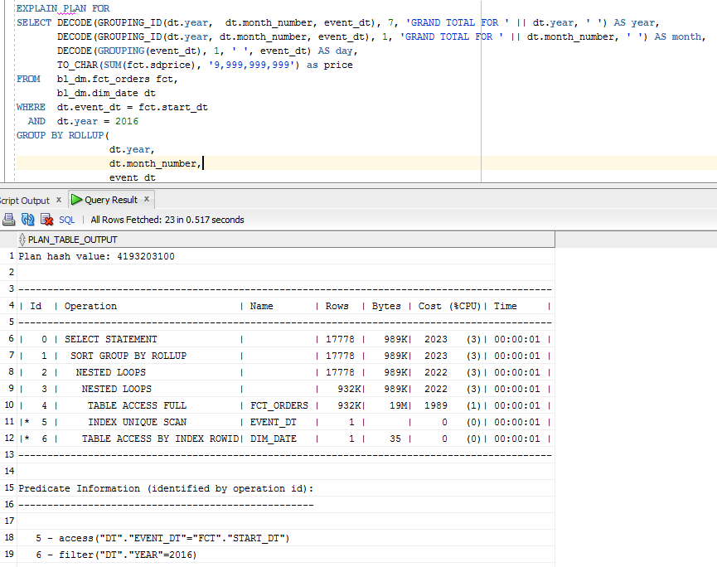

Partitioning by Years.

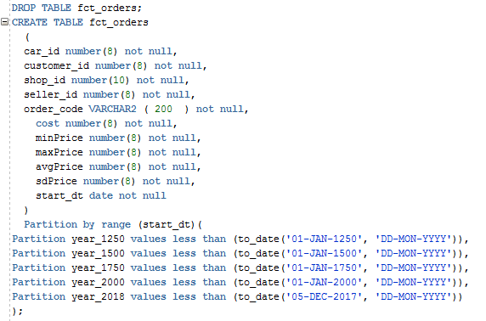

Result after partitioning

